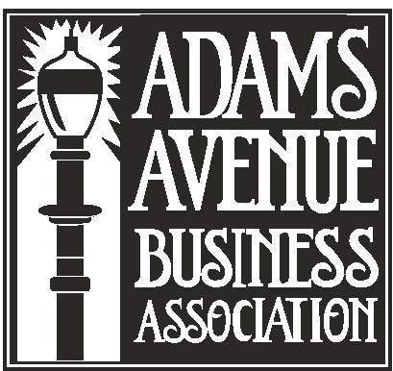
Adams Avenue Business Association: Board of Directors Meeting Agenda Tuesday March 6th
8:00 a.m. in the Normal Heights Community Center, 4649 Hawley Boulevard

Mikey Knab, PRESIDENT mikey@poncesrestaurant.com [ ]
Dave McPheeters, VICE PRESIDENT Dave.mcpheeters@gmail.com [ ]
Alison Flynn, 2nd VICE PRESIDENT aflynn42@gmail.com [ ]
Peggy Rose Levin, SECRETARY peggyrose.levin@gmail.com [ ]
Doug Generoli, TREASURER dgeneroli@gmail.com [ ]
Ryan Altman ryan@althealnet.org [ ]
Tony Carrillo t.carrillo@aol.com [ ]
Shayna Roberts shaynaroberts@gmail.com [ ]
Ed Badrak ebadrak@gmail.com [ ]
Phil Linssen FirstMasso@aol.com [ ]
Michael Rammelsberg rambetz@cox.net [ ]
Guy Hanford kenvideo@cox.net [ ]
Russ Vuich rvuich@cox.net [ ]

- Call to Order

- Introductions (1 minute)

- Action Items (5 minutes)
            - Approve January financials

D. Adjournment (Abbreviated meeting – Board of Directors to attend Annual Retreat)

AABA Committee Meeting Days & Times (All Committees meet in the AABA Office):
Promotions Committee – Second Thursday after the Board Meeting at 8:00am Mar 15
Business Planning & Development Committee – Third Tuesday of each month at 8:00am Mar 20
Finance Committee – Third Friday of each Month at 8:00am Mar 16
Executive Committee – Wednesday before the next Monthly Board Meeting at 8:00am Mar 28
Next Board Meeting: First Tuesday of every month 8:00am Apr 3

